Circuit 1: Three-Resistor Parallel Circuit

1. Gathering and Placing the Components
- First, I clicked on Component Mode (the yellow triangle icon) and pressed the 'P' button to open the device library.
- I searched for BATTERY, placed it on the workspace, and double-clicked it to set the voltage to 9V.
- Next, I searched for RES (resistor) and placed three resistors side-by-side.
- To make the parallel circuit easy to wire and read, I right-clicked each resistor and selected Rotate Clockwise so they were standing vertically.
- I double-clicked the resistors to set their specific values for this task: 10k, 2k, and 1k.
2. Placing the Measuring Instruments
- I opened Instruments Mode from the left toolbar and selected the DC Ammeter.
- Because I needed to measure the current in each branch, I placed one ammeter directly above each of the three resistors.
- Important Step: I double-clicked every single ammeter and changed the Display Range to Milliamps.
- I also selected a DC Voltmeter and placed it next to the first resistor to measure the voltage between Node 2 and Node 7.
- Finally, I went to Terminals Mode and placed a GROUND connection at the bottom of the workspace.
3. Wiring the Circuit
- I drew a long wire across the top, connecting the positive (+) terminal of the battery to the positive (+) pins of all three ammeters.
- I connected the negative (-) pin of each ammeter straight down into the top of its matching resistor.
- I drew a long wire across the bottom, connecting the bottom pins of all three resistors together, and routed it back to the negative (-) terminal of the battery and the ground.
- To finish, I connected the positive and negative pins of the voltmeter directly above and below the 10k resistor to measure the voltage drop.
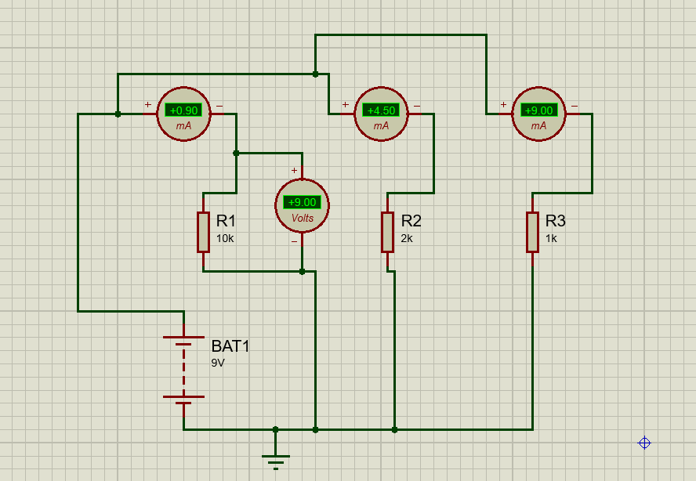

Circuit 2: Four-Resistor Parallel Circuit

1. Setting Up the Four Branches
- The setup for the second circuit was very similar to the first, but it required an extra parallel branch.
- I placed a new 9V battery and four standard resistors, rotating them all clockwise to stand vertically.
- I carefully set the values for the four resistors: 100 ohms (ensuring I didn't accidentally type 100k), 3k, 5k, and 10k.
2. Wiring and Measuring the Ladder Network
- I grabbed four DC Ammeters from Instruments Mode, set them all to Milliamps, and placed one above each resistor.
- I wired the circuit using the same parallel ladder structure: a single long top wire connected the positive battery terminal to all the ammeters, and a single long bottom wire connected all the resistors back to the negative battery terminal and ground.
- Finally, I placed a DC Voltmeter across the entire parallel network (connecting its positive pin to the top wire at Node 'a' and its negative pin to the bottom wire at Node 'e') to verify the total voltage across the branches.
